Founded in 2011, Five Stars Academy (FSA) is a private, highly-academic institution that combines the home-schooling philosophy of focusing on the individual student with the expertise of professional, experienced, certified teachers. We have the flexibility of choices expected in an experimental school while offering a U.S. Accredited Diploma with a partner school. FSA provides opportunities for students to learn self-sufficiency, to develop leadership skills and understand the impact they can have on their surroundings. Whether through classroom studies, mission work in and out of Panama, the diverse range of learning and growing opportunities available from living in the interior of Panama, or the student’s daily exposure to out-of-the-box thinking and problem solving, the goal is to tap into the best our students have to offer for themselves and for the World. With the average class size of less than 10 students to 1 instructor, we are able to maintain high expectations while providing individual support. Located in Santa Clara, Panama, 90 minutes west of Panama City, more than 25 countries comprise our student body. We began with 5 young students and have grown to 90+. Five Stars Academy graduated its first class of 5 in May 2019.
Director: Marie Claire Beauvil
E: info@fivestarsacademy.com | T: +507-6611-9510 | W: www.fivestarsacademy.com
Student Service  As one of Five Stars Academy's core values, service is an integral part of the student experience.  Community service is often done as an entire school, involving students, teachers and many parents. Service includes building homes in the mountains, beach cleanups and supporting the Boys House of Hope and the Girls House of Hope in Penonome, Panama.  Representing Five Stars Academy, our students have traveled to Haiti, the Dominican Republic, and Nicaragua to assist in managing day camps and feeding more than 500 children in each location. Through service, our students grow in an awareness of the cultural and social differences that make each community unique while learning humility, joy and respect. | At a Glance  Founded in 2011 | 100% English | Private college-prep school | Pre-K3 to Grade 12 | 12 Students in High School  Accreditation  - Minister of Education, Republic of Panama  - In partnership with Bridgeway Academy: AdvancEd International Accreditation and National Association of Private Schools  - Candidate for Accreditation with NCA CASI, NWAC, and SACS CASI  Student Nationalities Schoolwide  Argentina, Australia, Brazil, Belgium, Canada, Colombia, China, Cuba, England, Denmark, Finland, France, Germany, Holland, Honduras, India, Italy, Namibia, Panama, Peru, Philippines, Spain, South Africa, Venezuela, United States of America, Zambia
Location  Five Stars Academy is located 90 minutes west of Panama City, Republic of Panama. The interior of Panama provides a rich backdrop for innovative education. Away from the fast-paced life of the city, students are afforded the opportunity to discover who they are on the beaches and rain forests of this beautiful country. | 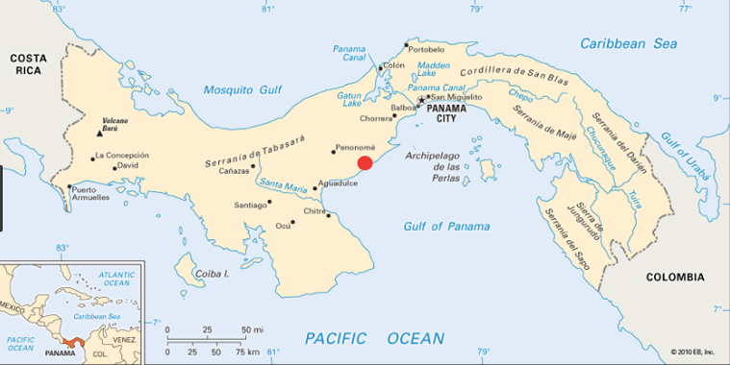
Graduation Requirements  High School students are able to receive a Panamanian High School Diploma or a U.S. Accredited High School Diploma upon graduation. To complete the requirements, they must fulfill the following plus 60 hours of community service.  Subject Credit  English: 4  Social Studies: 4  Math: 3 (4 recommended)  Science: 3 (including 2 labs)  World Language: 4  Electives: 5  Physical Education: 1  Total: 24 | Course Offerings  Due to our small school size, FSA Honors course offerings are limited. We offer AP courses online through our U.S. partnership. As our student body increases, FSA continues to explore and expand our higher academic course offerings to better serve students who are seeking new academic challenges. Talk to us directly to find out how we do this from our remote location. Honors courses receive an additional weighting of .33 when students achieve a C- or higher.  GPA  A = 4.00 100-90  B = 3.00 89-80  C = 2.00 79-70  D = 1.00 69-60
University Acceptances
Beginning with our first graduating class in May 2019, we have had students accepted to the following:
USA | International
University of Colorado - Boulder | University of Edinburgh (Scotland)
University of North Carolina - Chapel Hill | University of St. Andrews (Scotland)
University of Wisconsin - Madison | University of Bristol (England)
Monroe College | University of Paris (France)
Canada | Panama
McGill University | Technological University of Panama – UTP
University of Toronto
Concordia University
University of Waterloo

